After the Flood

Reading about weather in books is one thing, but living through a natural disaster was another. Even though the flood was not too bad, I was not prepared for what it was really like!

It all started two days ago. It was a rainy day, like every other rainy day I’ve ever remembered. The only unusual thing was how anxious the adults seemed to be getting. I started to pay more attention whenever I saw the news on at our house, at a restaurant, or anywhere else. The meteorologists kept saying that the rain hadn’t stopped in a long time, and it didn’t look like it was going to stop anytime soon. I didn’t really know what that meant for us, since Mom was always saying that rain was good for all the plants. The next morning, however, I began to understand.

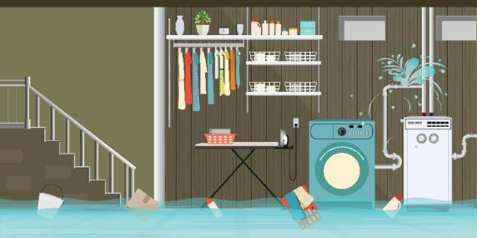I woke up and went down for breakfast. Usually, Mom or Dad was already eating by the time that I woke up, but neither of them was at the kitchen table, and the lights all over the house were off. *This is weird*, I thought. I went to get out the milk, but there was a note on the refrigerator telling me not to open the door. As I was wondering what I could eat for breakfast, I noticed that the rain was still going, and that I could hear noises coming from the basement. I went to investigate. Peeking through the basement door, I immediately stopped. There was *water* down there! I t didn’t look like a lot, but there were toys and things floating by! I could hear Mom and Dad’s voices.

“Hello? What’s going on down here?” I called down the stairs.

“Good morning, Vicky. All of this rain is causing some problems. The power all over town is out. Our basement is flooded, and so are some of the roads. A lot of houses have water in them, too,” Dad called back.

A little water didn’t seem too bad, and the power had gone out before,

so, I wasn’t too worried. Mom and Dad seemed to be taking care of it. They were talking about a pump, so I think they were getting the water out of the basement. I went to go play in my room.

Not too long after, Mom and Dad came back upstairs, changed their clothes, and washed their hands using hand sanitizer. I asked them what was going on.

“ Well, we pumped the water out by hand, but there’s some damage downstairs. We’re going to have to find some fans once the power comes back to try to dry out the basement as much as we can, but we might have to tear out the drywall and replace it. There are things that got all wet that we’re going to have to replace, too. I t’s quite the mess,” Mom said.

“ We’re also going to have to see i f we can get a generator, it looks like the power will probably be out for the rest of the day.”

We decided to drive around to see how other people in our town were doing. There were a lot of roads that were closed because of water covering the road, so we couldn’t get to the store. One bridge over the river was closed because water was rushing over i t! The houses by the river looked like they were *in* the river. We stopped to help people who were filling bags with sand. The bags helped to keep the water away.

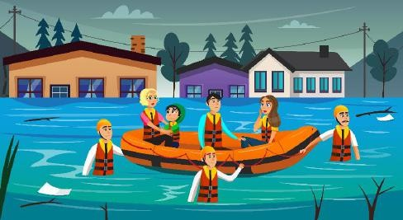

They said their neighbors across the street were in another town living with relatives until their house could be repaired. I couldn’t believe how much the flood was affecting us!

When we finished filling up sandbags, we drove back home.

“I can’t believe those people lost all of their clothes and household items. We should go through our stuff and see what we can donate. We’re lucky we only had a couple of inches of water in our basement, it could have been a lot worse,” said Dad. Mom and I agreed. Even though we didn’t have power and fixing the basement could get expensive, we were lucky.